# ERP FOR

**ROLLER FLOUR MILLS**

360 Degree Integrated Business Solution

Transforming Your Business: Streamline, Scale, and Succeed with our ERP System



[www.globalinfocloud.com](http://www.globalinfocloud.com/)

PARTNER



# ABOUT US

Global Infocloud is a business integrated company performing as a workhorse for the complete business ecosystem. We join hands with start-ups, SME's and fortune companies to beneﬁt them with our elite services in Business Automation, Design and Marketing.

We are a seasoned and talented team of IT, Marketing & Design who works on the principle of Discover, Learn & Evolve. We discover the new horizons for each of our client so that they can become a great leader and shift to the best from better.

We understand that each business has its own individual outlook and culture, thus we help client conceptualize, design, maintain, name and develop all their business needs.

Our services help you simplify your business complexity and maximize the value of your information. We build a trusted advisor relationship, based on experiences and best practice.

As IT automation has become the necessity in today's fast advancing era. So, we aim to automate your business and make you capable of providing an exceptionaluser experience to your clients.

Be it software development, online tech solutions,

mobility, analytics or IOT, we are there for you

Our Vertical Solutions expertise allows your business to streamline workﬂow and increase productivity.

No matter the business, Global Infocloud has everything you covered with the industry compliant solutions or customized to your company's speciﬁc needs.

# BENEFITS OF ERP

Unlock Success for Your Roller Flour Mills with These Must-Have ERP Capabilities

Our ERP solutions prioritize adaptability, easy usability, and high customization to meet the unique needs of your business, ensuring complete satisfaction.



**TAILORED SOLUTIONS**

**SCALABLE ARCHITECTURE**

**MODULE CUSTOMIZATION**

**SEAMLESS INTEGRATION**

**INDUSTRY- SPECIFIC FUNCTIONALITY**

**ONGOING SUPPORT & UPDATES**

Unifying all departments and their information into a single system, an ERP system brings forth a multitude of significant benefits.

**The notable benefits offered by us**

Streamlined Operations



Enhanced Collaboration



Improved Data Accuracy



Real-time Insights



Increased Productivity



Efﬁcient Resource Allocation



Effective Inventory



Management

Streamlined Financial Management

Improved Customer Relationship Management (CRM)

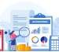

Enhanced Supply Chain Management



Regulatory Compliance

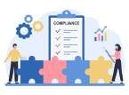

Scalability and Flexibility



Data Security



Enhanced Reporting and Analytics



**ERP FOR ROLLER FLOUR MILLS**

Unleashing the Power of ERP across Your Organization

**Procurement and Supply Chain Management:**



Streamlining procurementprocesses, supplier management, purchase order generation, and inventory replenishment.

Inventory Management:



Robust inventory control for tracking raw materials,including grains and additives, managing stock levels, and generating usage reports.

Production Planning and Control:



Efficient scheduling based on demandforecasts, optimizing resources, and real-time monitoring of production progress.

Quality Control:



Modules for capturing quality data at various stages, conductingtests, inspections, and generating quality reports.

Sales and Distribution Management:

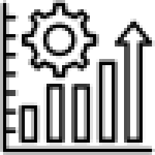

Order processing, sales tracking, delivery scheduling, invoicing, and integration with other systems.

Financial Management:



Accounting, budgeting, and financial reporting capabilitiesfor tracking costs, managing accounts, and generating statements.

Human Resource Management:



Streamlining HR processes, employee management, and talent acquisition.

**Maintenance and Repair Management:** Streamlining maintenance processes, equipment management, and repair activities.



Reporting and Analytics:



Customizable reports, KPI analysis, and insights for informed decision-making and monitoring performance.



## PROCUREMENT MANAGEMENT

 Supplier Management

* Centralized database of suppliers
* Contact information and performance metrics
* Evaluation and selection based on quality, pricing, and delivery capabilities

 Purchase Requisition

* Electronic creation and management
* Elimination of manual paperwork
* Accurate and timely submission of purchase requests
* Simplified approval workflow

 Purchase Order Generation

* Automation of creation and management
* Populating required information
* Supplier details, item specifications, quantities, and delivery dates
* Reducing errors and ensuring consistency

 Inventory Integration

* Seamless integration with inventory management system
* Maintaining optimal inventory levels
* Triggering purchase orders based on reorder points or forecasted demand
* Avoiding stock-outs or excess inventory

 Vendor Performance Evaluation

* Tracking and analysis of supplier performance
* On-time delivery, quality, and responsiveness
* Evaluating vendor performance and making informed decisions

 Purchase Order Tracking

* Real-time visibility into purchase order status
* Tracking progress from creation to delivery
* Better coordination with suppliers
* Proactive management of delays or issues

 Invoice Matching

* Matching purchase orders, goods receipt, and supplier invoices
* Verifying received goods and services against the order
* Ensuring accurate and timely payments
* Reducing discrepancies and potential fraud

 Cost Control and Analysis

* Insights into purchase history, costs, and expenditure patterns
* Analysis of spending and identification of cost-saving opportunities
* Negotiating better pricing with suppliers
* Optimization of procurement strategies

 Compliance and Documentation

* + Maintenance of procurement process documentation
  + Contracts, terms and conditions, and compliance requirements
  + Ensuring transparency and regulatory compliance
  + Supporting audits and legal requirements

## INVENTORY MANAGEMENT

Inventory Tracking

* Real-time monitoring of inventory levels
* Visibility into stock quantities, locations, and movements

Demand Planning and Forecasting

* Forecasting inventory
* Requirements based on historical data and sales trends
* Proactive inventory management to meet customer demands

Reorder Point and Stock Alerts

* Setting reorder points & automatic stock alerts
* Timely replenishment and avoidance of stockouts

Lot and Batch Tracking

* Tracking perishable or batch-controlled ingredients
* Capturing supplier, production batch, and quality control information

Inventory Valuation

* Supporting FIFO and weighted average cost methods
* Accurate valuation of inventory items

Inventory Optimization

* Analyzing demand patterns, lead times, and supplier performance
* Identifying slow-moving
* inventory and implementing just-in-time practices

Stock Transfers and Inter-Location Movements

* Facilitating stock transfers between multiple locations or warehouses
* Maintaining accurate stock levels across different locations

Inventory Reporting and Analysis

* Comprehensive inventory reports and analysis
* Insights into inventory performance and optimization opportunities

Integration with Procurement and Sales

* Seamless integration with procurement and sales modules
* Streamlined procurement processes and accurate inventory updates

## PRODUCTION MANAGEMENT



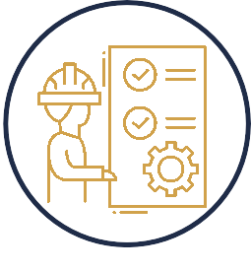**Production Planning**

**Bill of Materials (BOM) Management**

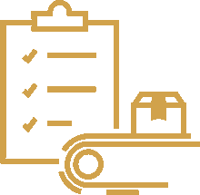

**Capacity Planning**

**Shop Floor Control**



**Work Order Management**

**Maintenance & Equipment Management**



**Real-time Production Monitoring**

**Quality Control**

## QUALITY CONTROL MANAGEMENT

###### QUALITY CONTROL PARAMETERS

* + **Defining and managing quality control parameters for each stage of the milling process**
  + **Specifications for moisture content, particle size, gluten content, and other quality attributes**

###### REAL-TIME QUALITY MONITORING

* + **Tools for real-time quality monitoring during the milling process**
  + **Capturing data on quality measurements, inspections, and test results**

###### LOT AND BATCH TRACEABILITY

* + **Tracking ingredients, raw materials, and finished products with lot and batchtraceability**
  + **Visibility into the origin of each lot or batch for recalls, investigations, and regulatory compliance**

###### QUALITY AUDITS AND INSPECTIONS

* + **Supporting quality audits and inspections with checklists, templates, and workflows**
  + **Ensuring compliance with quality standards, identifying non-conformities, and implementing corrective actions**

###### SUPPLIER QUALITY MANAGEMENT

* + **Tracking supplier performance, evaluating quality metrics, and monitoring suppliercompliance**
  + **Informed decisions about supplier selection and collaboration for continuous quality improvement**

###### NON-CONFORMANCE MANAGEMENT

* + **Managing non-conformances, deviations, and corrective actions**
  + **Documenting and tracking non-conformities, initiating corrective actions, and improving process quality**

###### DOCUMENT CONTROL

* + **Managing quality-related documents, such as SOPs, work instructions, and quality manuals**
  + **Ensuring accessibility to the latest versions and maintaining standardized processes**

###### STATISTICAL PROCESS CONTROL (SPC)

* + **Analyzing process data and identifying variations or trends impacting product quality**
  + **Implementing statistical control methods, monitoring process stability, and improving process capability**

###### REGULATORY COMPLIANCE

* + **Integrating quality standards and regulatory requirements into quality controlprocesses**
  + **Automating compliance checks, generating compliance reports, and maintaining audit trails**

**SALES AND MARKETING MANAGEMENT**



**Sales Pipeline Management**

**Customer Segmentation and Targeting**

**Customer Service and Support**

**Sales Analytics and Reporting**



**Customer Data Management**



**Order Management**



**Marketing Campaign Management:**



**Opportunity and Forecast Management**

#### DISPATCH AND TRANSPORTATION MANAGEMENT

###### Efficient Delivery Planning Real-Time Shipment Tracking



**Load Planning and Optimization Documentation and Compliance Fleet Management**

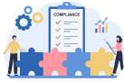

###### Customer Communication Performance Analysis



**Route Planning and Optimization Carrier Management**

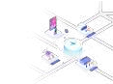

###### Freight Rate Management Shipment Tracking and Visibility Documentation and Compliance Freight Audit and Payment Return and Reverse Logistics

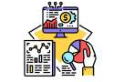

**Analytics and Reporting**

### VENDOR AND BROKER MANAGEMENT

###### Vendor Management

* Maintaining a vendor database with contact information, payment terms, delivery terms, and performance history
* Selecting reliable vendors, negotiating contracts, and ensuring timely and quality supplies

###### Purchase Order Management

* Creating, tracking, and managing purchase orders
* Generating electronic purchase orders, communicating with vendors, and tracking order status
* Ensuring accurate order processing, reducing manual errors, and improving purchasing efﬁciency

###### Vendor Performance Evaluation

* Capturing data on delivery performance, supply quality, pricing, a responsiveness
* Measuring and analyzing vendor performance
* Identifying areas for improvement and making informed decisions on vendor selection and relationship management

###### Price and Contract Management

* Managing vendor pricing and contracts
* Maintaining negotiated prices, monitoring price changes, and tracking contract terms and conditions
* Ensuring accurate pricing, minimizing discrepancies, and improving contract compliance

###### Vendor Collaboration

* Facilitating collaboration and communication with vendors
* Providing vendor portals or communication channels for information exchange, order conﬁrmations, and delivery

schedule updates

* Enhancing transparency, reducing communication errors, and fostering better collaboration with vendors

###### Broker Management

* Managing brokers or intermediaries (if applicable)
* Maintaining broker information, tracking broker performance, and managing commissions or fees
* Optimizing broker relationships and ensuring effective coordination in procurement or sales processes

###### Payment and Invoice Management

* Managing vendor payments and invoices
* Automating invoice veriﬁcation, matching with purchase orders, and initiating payment workﬂows
* Improving accuracy, reducing payment delays, and streamlining accounts payable processes

###### Vendor Relationship Analysis

* Providing analytics and reporting capabilities for vendor performance, purchasing patterns, and vendor spend
* Identifying opportunities for cost savings, negotiating better terms, and strategically managing vendor relationships

### FINANCE AND ACCOUNTING MANAGEMENT

#### General Ledger

* Maintaining a centralized general ledger for accurate and up-to-date ﬁnancial records
* Automating the recording of ﬁnancial transactions, revenue, expenses, and asset management
* Ensuring data integrity and providing a comprehensive view of the organization's ﬁnancial health

#### Accounts Payable

* Streamlining the accounts payable process through automation of invoice processing, payment approvals, and vendor management
* Facilitating timely payments, reducing manual

errors, and improving cash ﬂow management

#### Accounts Receivable

* Managing customer invoicing, payment collection, and receivables tracking
* Enabling timely and accurate billing, improving collections management, and enhancing cash ﬂow visibility

#### Financial Reporting

* Generating ﬁnancial statements, balance sheets, income statements, and cash ﬂow

statements

* Providing insights into ﬁnancial performance, proﬁtability, and key ﬁnancial indicators
* Facilitating informed decision-making

###### Budgeting and Forecasting

* Supporting budgeting and forecasting processes, including budget creation, resource allocation, and performance monitoring
* Tracking expenses, identifying variances, and aligning ﬁnancial goals with strategic objectives

###### Fixed Assets Management

* Tracking and managing ﬁxed assets, including depreciation calculations, lifecycle management, and maintenance scheduling
* Ensuring accurate asset valuation, compliance with accounting standards, and efﬁcient asset utilization

**Financial Controls & Compliance**

* Incorporating ﬁnancial controls and compliance features, such as audit trails, segregation of duties, and regulatory compliance checks
* Ensuring adherence to ﬁnancial regulations

and internal control standards, reducing

the risk of fraud or ﬁnancial mismanagement

###### Cost Analysis

* Providing tools for cost analysis, expense
* evaluation, and identiﬁcation of cost drivers
* Facilitating informed decisions to optimize costs, monitor proﬁtability, and identify opportunities for cost reduction

### HUMAN RESOURCE MANAGEMENT

**EMPLOYEE INFORMATION MANAGEMENT**



**RECRUITMENT AND ONBOARDING**



**EMPLOYEE SELF-SERVICE**



**TIME AND ATTENDANCE MANAGEMENT**



**PAYROLL AND BENEFITS ADMINISTRATION**



**PERFORMANCE MANAGEMENT**



**TRAINING AND DEVELOPMENT**



**COMPLIANCE AND REPORTING**



**EMPLOYEE ENGAGEMENT AND COMMUNICATION**



### MAINTENANCE AND REPAIR MANAGEMENT

 Comprehensive Asset Tracking

* + Centralized repository of equipment and asset information
  + Detailed maintenance history and documentation
  + Enhanced visibility into equipment lifecycle and depreciation

 Cost Savings and Expense Control

* + Lower repair and replacement costs
  + Efficient utilization of equipments and resources
  + Reduced emergency maintenance and associated expenses

 Preventive Maintenance

* + Scheduled inspections, cleaning, and lubrication
  + Calibration and adjustment of equipment components
  + Early detection of potential issues to prevent breakdowns

 Planned Downtime and Shutdowns

* + Strategic planning of equipment maintenance activities
  + Coordinated shutdowns to minimize production disruptions
  + Timely replacement of critical components or parts

 Compliance with Regulatory Standards

Adherence to safety and environmental regulations

Documentation of maintenance activities for audits

Implementation of industry best practices

Enhanced Equipment Documentation

Accurate and up-to-date equipment records

Maintenance history and documentation

Easy retrieval of information for future reference

Predictive Maintenance

Utilization of condition monitoring techniques

Analysis of equipment data for predictive insights

Timely intervention to address emerging problems

Safety and Risk Management

Improved equipment safety and reliability

Compliance with safety regulations and standards

Minimized risk of accidents and injuries

Extended Equipment Lifespan

Proper maintenance and timely repairs

Reduction in wear and tear of equipment

Preservation of capital investments

### OUR CLIENTS



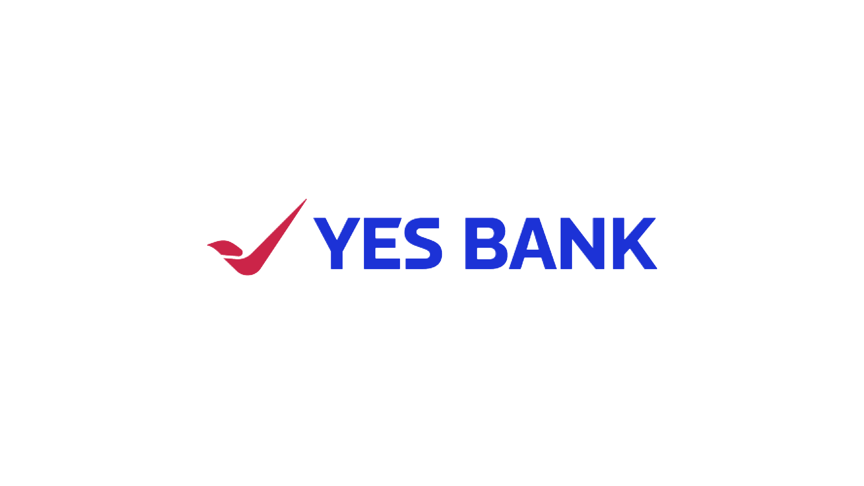

**ADDRESS:**

Corporate Office:

Global Infocloud Pvt Ltd, 418-423, Gera Imperium Rise, Wipro Circle, Hinjewadi Ph-II, Pune - 411057, Maharashtra, India

Regional Office:

7 Mackeller Court, Ajax, Ontario, Canada, L1T0G2

**CONTACT:**

+91 22 351 550 01

+91 91 517 444 75

##### [hello@globalinfocloud.com](mailto:hello@globalinfocloud.com) [www.globalinfocloud.com](http://www.globalinfocloud.com/)

PARTNER

IT Automation | Marketing | Design

Discover . Learn . Evolve